**Data Flow Diagrams:**

**Project Design Phase-II**

**Data Flow Diagram**

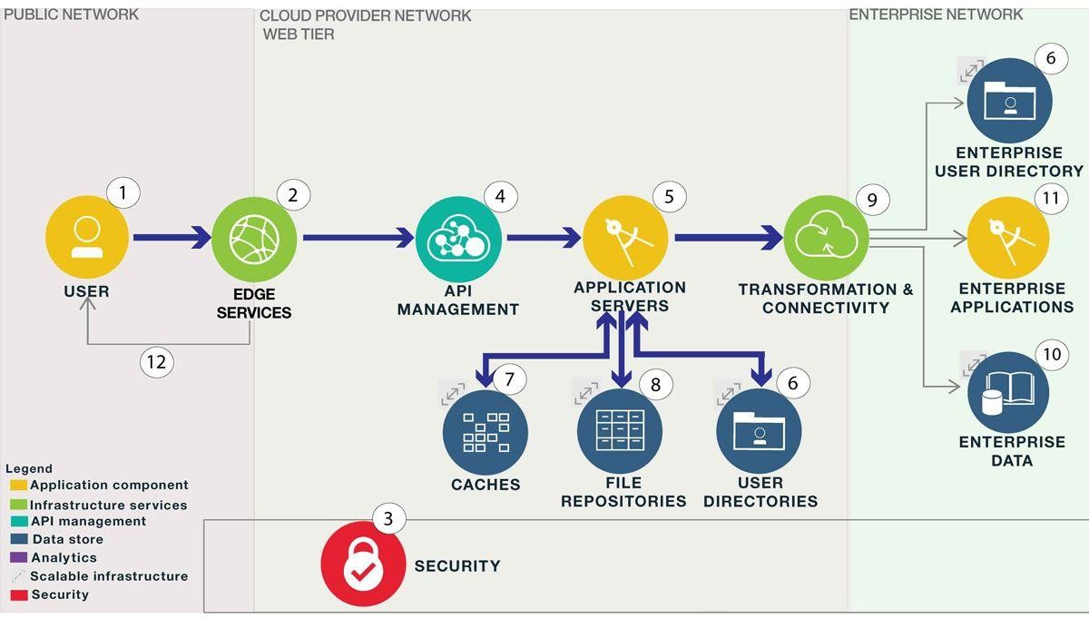

**USER**

Fulfillment

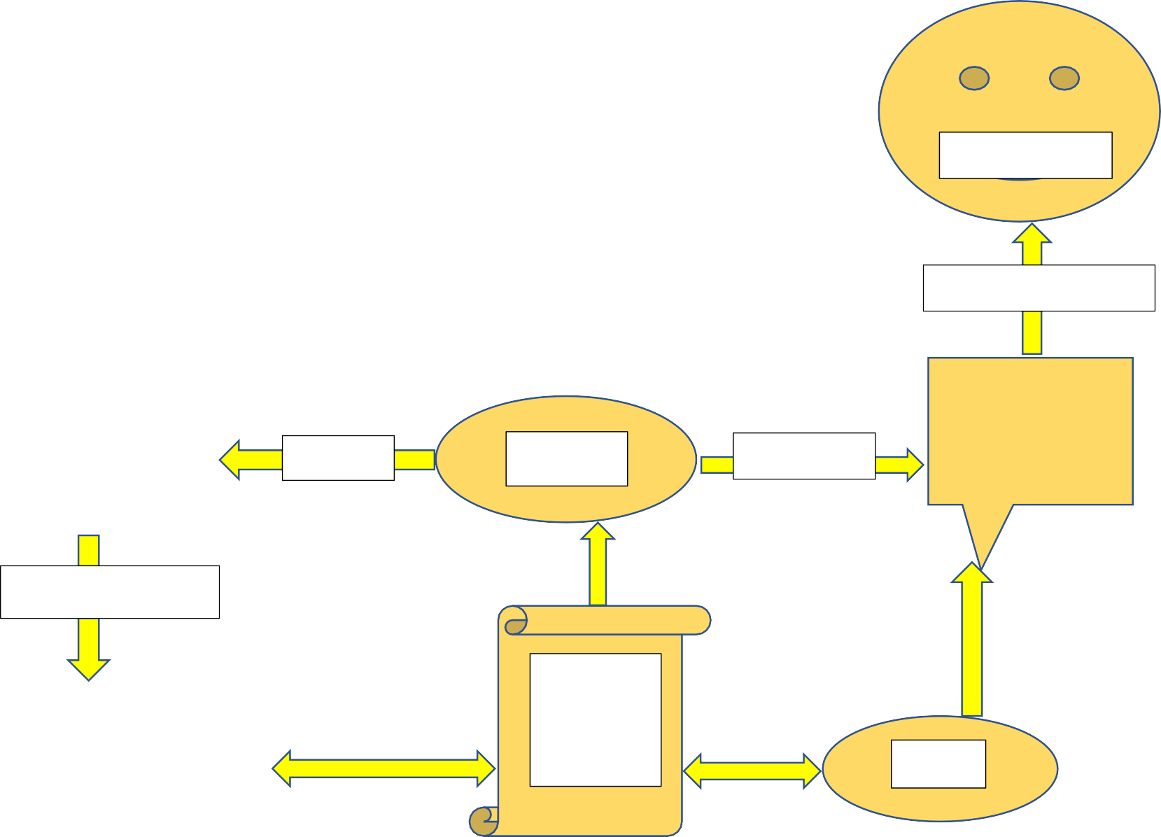

Feedback Form

Download Application

Update

**Install Application**

# USER

Any issues

**HELP !**

Create Account

**Guide**

**Lines USER**

**Instruction**